**BELAGAVI**



***Web Technology & It’s Application(18CS63) Project Based Learning Report On***

***“College platform”***

*Submitted in the partial fulfillment for the requirements of Web Technology of 6th semester CSE requirement in the form of the Practical Assessment*

**BACHELOR OF ENGINEERING**

In

**COMPUTER SCIENCE AND ENGINEERING**

*By*

**Megha Gupta Nisar Ahmed P**

**(1BY20CS108) (1BY21CS412)**

**Mohammed Bawazir K Prajwal Reddy**

**(1BY20CS113) (1BY20CS077)**

*Under the guidance of*

**Mr. MUNESHWARA M S**

Assistant Professor, Department of CSE, BMSIT&M



**DEPARTMENT OF COMPUTER SCIENCE AND ENGENEERING**

**B.M.S. INSTITUTE OF TECHNOLOGY & MANAGEMENT**

**YELAHANKA, BENGALURU-560064 2022-2023**

# BELAGAVI

## BMS INSTITUTE OF TECHNOLOGY &MANAGEMENT

**YELAHANKA, BENGALURU – 560064**



CERTIFICATE

This is to certify that the Project work entitled **“College Platform**” is a Bonafede work carried out by **Mohammed Bawazir(1BY20CS113), Megha Gupta(1BY20CS108), Nisar Ahmed P (1BY21CS412) and K Prajwal Reddy(1BY20CS077)** in partial fulfillment for Web Technology Project Based Learning during the year 2022-2023. It is hereby certified that this project covers the concepts of Web Technology and its Applications (18CS63). It is also certified that all corrections/suggestions indicated for Internal Assessment have been incorporated in this report.

**Signature of the Guide Signature of the HOD**

**Mr. Muneshwara M S Dr. Thippeswamy G**

Assistant Professor, Professor & HOD,

Dept. of CSE, BMSIT&M Dept. of CSE, BMSIT&M

## INSTITUTE VISION

To emerge as one of the finest technical institutions of higher learning, to develop engineering professionals who are technically competent, ethical and environment friendly for betterment of the society.

## INSTITUTE MISSION

Accomplish stimulating learning environment through high quality academic instruction, innovation and industry-institute interface.

## DEPARTMENT VISION

To develop technical professionals acquainted with recent trends and technologies of computer science to serve as valuable resource for the nation/society.

## DEPARTMENT MISSION

Facilitating and exposing the students to various learning opportunities through dedicated academic teaching, guidance and monitoring.

## PROGRAM EDUCATIONAL OBJECTIVES

1. Lead a successful career by designing, analyzing and solving various problems in the field of Computer Science & Engineering.
2. Pursue higher studies for enduring edification.
3. Exhibit professional and team building attitude along with effective communication.
4. Identify and provide solutions for sustainable environmental development.

## PROGRAM SPECIFIC OUTCOMES

1. Analyze the problem and identify computing requirements appropriate to its solution.
2. Apply design and development principles in the construction of software systems of varying complexity.

**ACKNOWLEDGEMENT**

Any achievement, be it scholastic or otherwise does not depend solely on the individual efforts but on the guidance, encouragement and cooperation of intellectuals, elders and friends. A number of personalities, in their own capacities have helped us in carrying out this project work. We would like to take this opportunity to thank them all.

We express our sincere gratitude to **Dr. Mohan Babu G.N, Principal, BMSIT & M** for providing all the facilities and the support.

We heartily thank to **Dr. Thippeswamy G, Head of Department, Department of Computer Science and Engineering, BMSIT&M** for his constant encouragement and inspiration in taking up this topic for project.

We heartily thank to our Project Based Learning Coordinator **Prof. Vishakha Yadav, Assistant professor, Department of Computer Science and Engineering, BMSIT&M** for her constant encouragement and monitoring in taking up this topic for project.

We gracefully thank to our guide **Mr. Muneshwara M.S, Assistant professor, Department of Computer Science and Engineering, BMSIT&M** for encouragement and advice throughout the project work.

Special thanks to all the **staff members of Computer Science Department** for their help and kind co- operation.

Last, but not the least, we thank our **parents and friends** for their encouragement and support given to us in order to finish this project work.

Mohammed Bawazir (1BY20CS113)

Megha Gupta (1BY20CS108)

Nisar Ahmed P (1BY21CS412)

K Prajwal Reddy (1BY20CS077)

**ABSTRACT**

The web application offers a range of features tailored to meet the specific needs of college environments. Students can access their course schedules, view grades, and submit assignments electronically. They can communicate with peers and faculty members through integrated messaging systems, discussion forums, and virtual classrooms. Additionally, the application provides a platform for students to explore extracurricular activities, join clubs, and stay updated on campus events.

For faculty members, the College Platform Web Application offers tools to manage course materials, conduct assessments, and provide feedback to students. It simplifies the process of grade management, streamlines attendance tracking, and supports efficient communication with students and colleagues. The application also includes collaborative features such as document sharing, allowing faculty members to work together on research projects and curriculum development.

Administrators can utilize the web application to streamline administrative tasks such as student registration, course scheduling, and resource allocation. They can generate reports, track student progress, and ensure compliance with academic policies. The platform also facilitates campus-wide announcements, event management, and coordination of campus services.

**TABLE OF CONTENTS**

|  |  |  |
| --- | --- | --- |
| **CHAPTER NO** | **TITLE** | **PAGE NO** |
| **CHAPTER 1** | **INTRODUCTION** | **1** |
|  | 1.1 Brief Introduction | **1** |
|  | 1.2 Motivation | **1** |
|  | 1.3 Scope | **2** |
|  | 1.4 Problem Statement | **2** |
|  | 1.5 Proposed System | **3** |
|  | 1.6 Limitations | **3** |
| **CHAPTER 2** | **LITERATURE SURVEY** | **4** |
| **CHAPTER 3** | **SYSTEM REQUIREMENT** | **6** |
| **CHAPTER 4** | **SYSTEM ANALYSIS** | **9** |
| **CHAPTER 5** | **SYSTEM IMPLEMENTATION** | **10** |
| **CHAPTER 6** | **INTERPRETATION OF RESULTS** | **12** |
| **CHAPTER 7** | **CONCLUSION** | **13** |
| **CHAPTER 8** | **FUTURE ENHANCEMENTS** | **14** |
|  | **BIBLIOGRAPHY** | **15** |

**CHAPTER 1**

# INTRODUCTION

Brief introduction to the project including the idea behind it is explained in this chapter.

## Brief Introduction

The College Platform Web Application is a robust and user-friendly online platform designed to cater to the needs of college students, faculty, and administration. It serves as a centralized hub for various activities and services related to academic, administrative, and social aspects of college life.

This web application aims to enhance communication, streamline processes, and provide easy access to essential resources for all stakeholders within the college community. It leverages the power of technology to create a seamless and efficient environment that promotes collaboration, engagement, and academic success.

* 1. **Motivation**

The most common reasons for the people to travel away from home are:

* + - A college platform web application can motivate students by providing a platform that fosters

collaboration among peers To visit friends and relatives

* + - The web application can offer personalized learning experiences tailored to individual students'

needs and preferences.

* + - Incorporating progress tracking features and providing regular feedback can motivate students

by allowing them to see their growth and improvement over time.

* + - The web application should offer interactive and multimedia-rich content to make the learning

experience engaging and enjoyable.

* + - Building features that allow students to recognize and support their peers can boost motivation.

.

## Scope

A college platform web application can offer various features and functionalities to enhance the college experience for students, faculty, and administrators. Here are some potential scopes for a college platform web application:

Online Courses and Learning Management System (LMS): Incorporate an LMS that allows students to enroll in online courses, access course materials, submit assignments, take quizzes and exams, and participate in virtual discussions. Provide features like progress tracking, grades, and certificates upon completion.

**1.4 Problem Statement**

The problem statement for a college platform web application revolves around addressing the challenges faced by students, faculty, and administrators in effectively managing and accessing various aspects of college life. These challenges include inefficient communication channels, disorganized course materials, limited collaboration opportunities, cumbersome administrative processes, and a lack of centralized information hub. The aim of the web application is to create a comprehensive platform that streamlines and enhances communication, facilitates easy access to course materials and resources, encourages collaboration among students and faculty, simplifies administrative tasks, and serves as a centralized hub for all college-related information. By addressing these challenges, the web application seeks to improve overall efficiency, productivity, and the overall college experience for all stakeholders involved.

Currently, organizations heavily rely on email exchanges, scattered messaging apps, and physical notice boards, which often lead to information overload, miscommunication, and missed deadlines. These disparate systems make it challenging to maintain clear lines of communication, locate relevant information quickly, and track the progress of shared tasks and projects.

Furthermore, with the rise of remote work and geographically dispersed teams, the need for a digital platform that fosters collaboration and strengthens connections among colleagues has become even more critical. Traditional methods of communication fall short in facilitating real-

time interactions, virtual meetings, and a sense of community among colleagues who may not have the opportunity to physically interact on a regular basis.

Implementing such an advanced online tourism management system would revolutionize the industry by improving the overall travel experience for users and boosting operational efficiency for businesses.

## Proposed System

The We propose the development of a comprehensive college platform web application that aims to enhance the overall college experience for students, faculty, and administrators. This proposed system will serve as a centralized hub, providing a wide range of features and functionalities to streamline communication, collaboration, and access to resources.

The web application will have a user-friendly interface with personalized profiles for students, faculty, and administrators. Students will be able to access their course schedules, view grades, and submit assignments online. The platform will also facilitate communication between students and faculty through discussion forums, messaging systems, and virtual classrooms for remote learning.

• Gives accurate information

• Simplifies the manual work

• It minimizes the documentation related work

• Provides up to date information

## Limitations

Limited Customization: Many college platform web applications have limited customization options, restricting the ability to personalize the interface or tailor it to specific institutional needs.

Scalability Challenges: As the number of users and data on the platform increases, some college platforms may struggle with scalability issues, leading to slow response times or system crashes during peak usage periods.

Integration Difficulties: Integrating a college platform with existing systems and databases can be challenging, especially if the platform lacks comprehensive APIs or compatible protocols. This can hinder data synchronization and create inefficiencies.

Security Concerns: College platform web applications often handle sensitive student information, such as grades, personal details, and financial data. Ensuring robust security measures to protect against data breaches and unauthorized access is crucial but can be a significant challenge.

User Adoption and Training: Introducing a new college platform web application to an entire institution may face resistance or difficulties in user adoption. Adequate training and support resources should be provided to help faculty, staff, and students navigate and utilize the platform effectively.

**CHAPTER 2**

# LITERATURE SURVEY

**1. Paper: "The Impact of Online College Platforms on Student Learning"**

Authors: Cavanaugh, J.

Published in: Online Learning, 2019.

**Summary:** Cavanaugh (2019) examines the impact of online college platforms on student learning outcomes. The study highlights how these platforms enhance student engagement, provide access to supplementary learning materials, and support self-paced learning.

**2. Paper: "Predicting College Student Engagement using Quizzes in an Online Learning Environment"**

Authors: Cho, K., Heron, M.

Published in: Online Learning, 2020.

**Summary:** Cho and Heron (2020) investigate the predictive power of quizzes on online college platforms regarding student engagement and academic performance. The study reveals that active participation in quizzes leads to higher engagement and improved learning outcomes.

**3. Paper: "Effectiveness of Online Quizzes for Student Learning in Higher Education: A Meta-analysis"**

Authors: Huang, Y. M., Liang, T. H., Su, Y. N.

Published in: Computers & Education, 2021.

**Summary**: Huang et al. (2021) conduct a meta-analysis to assess the effectiveness of online quizzes in higher education. The research demonstrates that online quizzes contribute to student learning by providing assessment opportunities and immediate feedback.

**4.** **Paper: "A Study of Student Generated Content in an Online Platform"**

Author: Loizou, M.

Published in: Computers & Education, 2019.

**Summary:** Loizou (2019) investigates the quality and accuracy of student-generated content, such as notes and quiz questions, in online college platforms. The study emphasizes the importance of ensuring the integrity of user-generated materials.

**5. Paper "Interface Design Guidelines for Educational Online Platforms: A Systematic Literature Review"**

Authors: Maier, K. S., Schmitt, M., Holzer, A. M.

Published in: Educational Technology Research and Development, 2020.

**Summary:** Maier et al. (2020) conduct a systematic literature review on interface design guidelines for educational online platforms. The research highlights the significance of clear organization and labeling of notes, quizzes, and enquiry features to improve usability.

**6. Paper: "Usability of Responsive Design e-Learning Platforms"**

Authors: Morales-Ramirez, I. P., Rubio, L., Lopez, M.

Published in: Education and Information Technologies, 2019.

**Summary:** Morales-Ramirez et al. (2019) examine the usability of responsive design in e-learning platforms. The study emphasizes the importance of mobile compatibility and responsive design for enhancing convenience and engagement.

**CHAPTER 3**

# SYSTEM REQUIREMENT

## Hardware Requirements

* + Processor: Pentium 4 dual processor CPU or AMD
  + Main Memory (RAM): 4GB
  + Cache memory: 4 MB
  + Keyboard: 108 keys
  + Mouse: Optical mouse
  + Hard disk: 200GB
  + Monitor: LCD or LED display

## Software Requirements

* + - Windows OS
    - Visual Studio Platform
    - MYSQL server
    - Front End: PHP, HTML, Bootstrap, JavaScript
    - Backend: MySQL
    - Browser: Google Chrome, Mozilla Firefox , PHP, JavaScript Flash Compatible Browser
    - Connectivity: Internet
    - Server: Apache

## Functional Requirements

**1. User Registration and Authentication:**

**-** The system should allow users to create an account and provide necessary information for

registration.

- Users should be able to authenticate themselves using credentials such as username and

password.

- The system should enforce proper security measures, including password hashing and

session management.

**2. User Profile Management:**

- Users should be able to view and update their profile information, such as name, contact

details, and profile picture.

- The system should provide privacy settings for users to control the visibility of their profile

information.

**3. Course Management:**

- The system should allow administrators to create and manage courses offered by the

college.

- Users should be able to view course details, including course descriptions, prerequisites,

and schedules.

- Students should be able to enroll in courses, and the system should track their course

registrations.

**4. Class Scheduling and Attendance:**

- The system should provide a feature for scheduling classes and managing the timetable.

- Students should be able to view their class schedule, including dates, times, and locations.

- The system should support attendance tracking, allowing instructors to mark attendance

for each class.

**5. Assignment and Grading:**

- Instructors should be able to create assignments and specify submission deadlines.

- Students should be able to submit their assignments online.

- Instructors should be able to grade the assignments and provide feedback to students.

- The system should calculate and maintain the overall grade for each student in a course.

**6. Communication and Collaboration:**

- The system should provide communication tools, such as messaging or discussion forums,

for users to interact with each other.

- Instructors should be able to send announcements or notifications to their students.

- The system should support file sharing and collaborative workspaces for group projects.

**7. Resource Management:**

- The system should allow instructors to upload and share course materials, such as lecture

slides, documents, and multimedia files.

- Students should be able to access and download the shared resources for their enrolled

courses.

## Non - Functional Requirements

* + - The system must use the internet.
    - The system should be secure for usage.
    - The system must have a GUI usable by the user.
    - The system must enable scalability of the software.
    - The system should maintainable and provide support.

**CHAPTER 4**

# SYSTEM ANALYSIS

During System analysis for a college platform web application involves a comprehensive evaluation of the system's requirements, processes, and functionalities. It aims to identify the current state of the application, understand user needs, and propose improvements.

The analysis begins with gathering requirements through discussions with stakeholders, including college administrators, faculty, and students. These requirements can include features such as course registration, online learning materials, assignment submission, discussion forums, and grade tracking.

Next, the existing system is examined to determine its strengths and weaknesses. This involves assessing the user interface, database structure, security measures, performance, and scalability. It also includes identifying any bottlenecks or limitations in the current system that may affect user experience or efficiency.

To ensure the proposed improvements align with user expectations, user feedback and usability testing can be conducted. This helps to identify pain points and areas where the application can be optimized for better user engagement and satisfaction.

During the system analysis, data flow diagrams or process flowcharts can be created to visualize the information flow within the application. This helps in understanding the interaction between different modules, data inputs, processing steps, and outputs.

Furthermore, integration points with external systems, such as student information systems or learning management systems, should be considered. This enables seamless data exchange and ensures a cohesive ecosystem for the college platform.

**CHAPTER 6**

## INTERPRETATION OF RESULTS

## Login modal :

|  |
| --- |
|  |
|  |  |

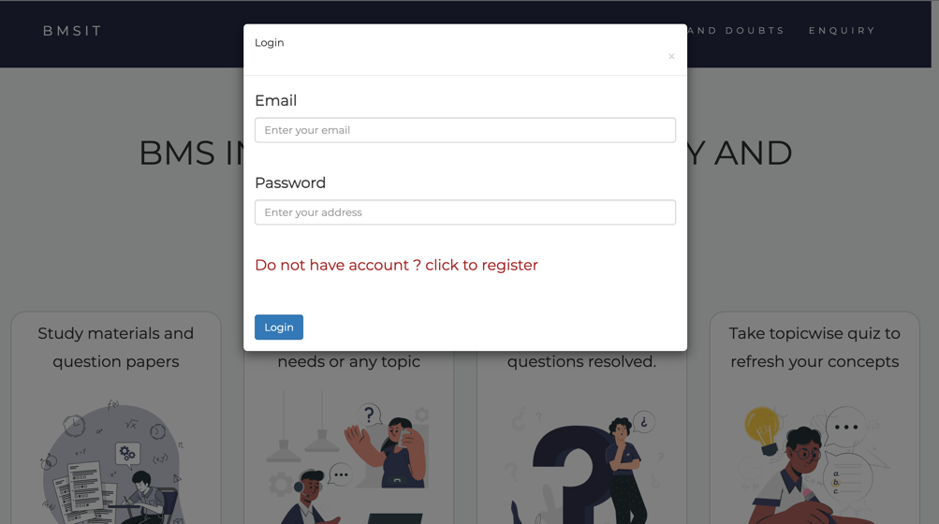This is the window that’s opens when the student clicks login link. This displays login page of our website.

         Fig 6.1 Login Page of Online College Platform

**Home page:**

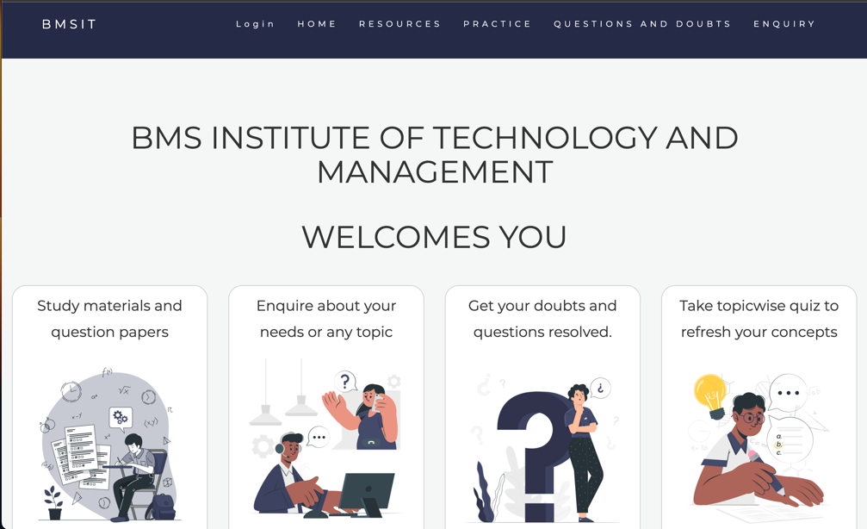This is the first window when the application is executed. This displays login pageof ourwebsite**.**

Fig 6.2 Home Page of our website

|  |
| --- |
|  |
|  |  |

**Take A Test Page:**

This is take test page. This includes multiple pages including choose semester, department and subject page

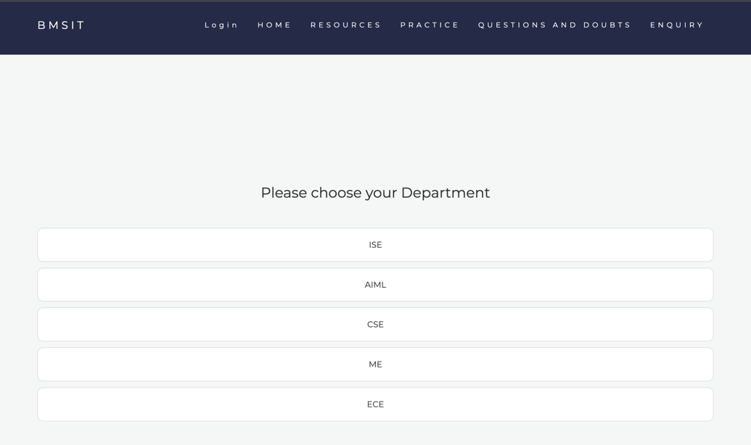

Fig 6.3 Choose Department Page

**Choose Semester Page:**

This is choose semester page, from which the student will choose the semester to view the subjects



Fig 6.4 Choose Semester Page

**Question Page:**

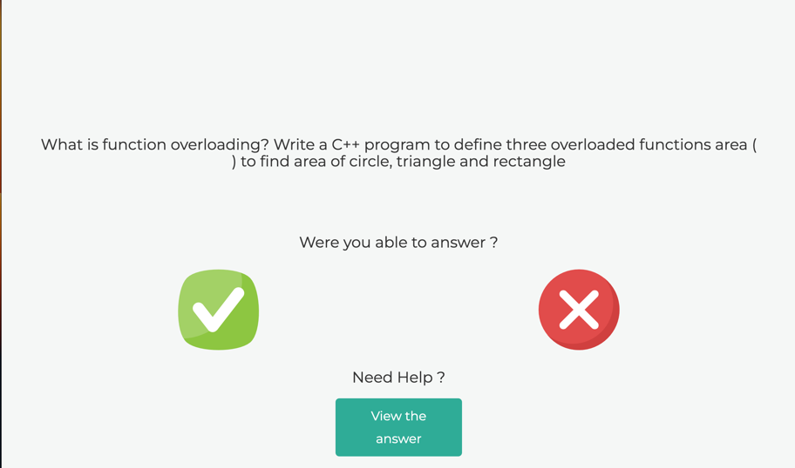This is question page when user selects the department, semester and subject.

Fig 6.5 Question Page

**Notes Page:**

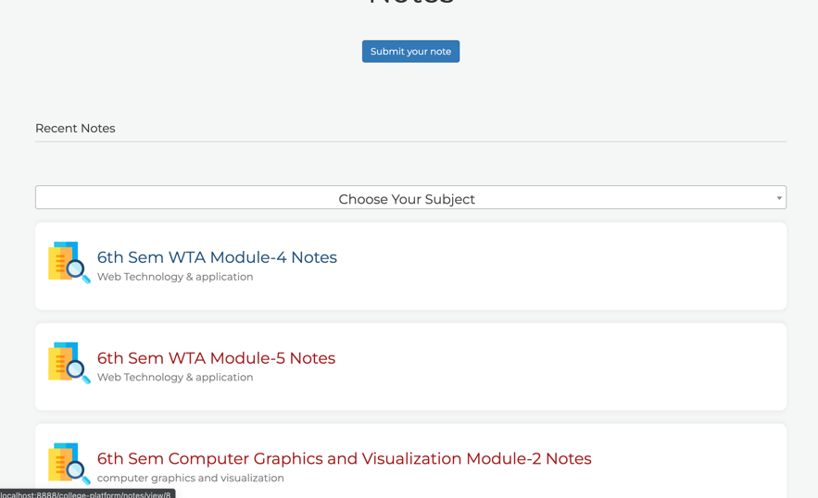This is view notes page to view notes including filters by subject name.

Fig 6.6 Notes Page

**View Note Page:**

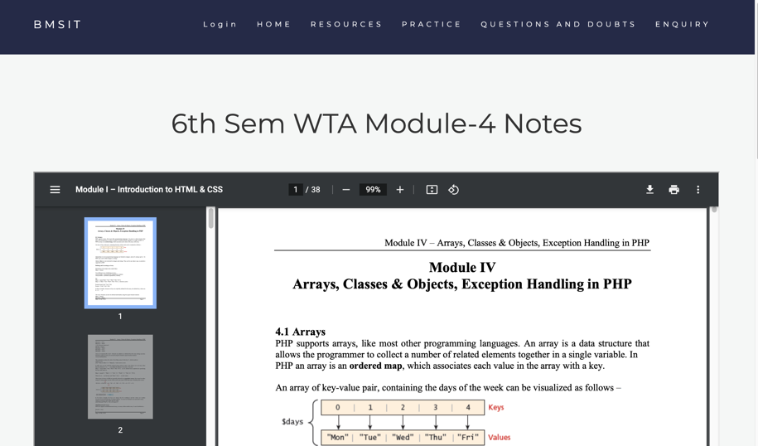This is view note page to view the soft copy notes.

Fig 6.7 Question Page

**Enquiries Page:**

This is view enquiries page where all student’s enquiries will be shown.

Fig 6.8 Notes Page

**CHAPTER 5**

# SYSTEM IMPLEMENTATION

The interpretation of results for a college platform web application is crucial in understanding its performance, usability, and overall effectiveness. By analyzing various metrics and user feedback, we can gain insights into how well the application is meeting its intended goals and identify areas for improvement.

One aspect of result interpretation involves assessing the application's performance. This includes analyzing metrics such as page load times, server response times, and resource utilization. By examining these metrics, we can determine if the application is delivering a smooth and responsive user experience. Any bottlenecks or performance issues can be identified and addressed to optimize the application's speed and efficiency.

Additionally, user feedback plays a vital role in result interpretation. Gathering feedback through surveys, user interviews, or usability testing helps understand the user's perspective and satisfaction level. This feedback provides valuable insights into the application's usability, user interface design, and overall user experience. By analyzing this feedback, we can identify pain points, usability issues, and user preferences, allowing us to make informed decisions about necessary improvements.

Furthermore, tracking key performance indicators (KPIs) related to the application's goals is crucial for result interpretation. For a college platform web application, KPIs may include metrics such as user engagement, course enrollment rates, completion rates, and student satisfaction. By monitoring these KPIs, we can assess the application's effectiveness in facilitating student engagement, promoting course participation, and improving overall satisfaction levels. Analyzing these metrics helps identify areas where the application excels and areas that require attention.

**CHAPTER 7**

# CONCLUSION

In conclusion, enhancing the non-functional aspects of your college platform web application is crucial for providing a seamless user experience and ensuring its overall effectiveness. By focusing on performance optimization, scalability and availability, security measures, accessibility compliance, error handling and logging, as well as cross-browser and cross-device compatibility, you can create a robust and user-friendly application.

Efficient performance optimization techniques will enable faster loading times and smooth interactions, keeping users engaged. Scalability and availability measures will ensure that your application can handle increasing user traffic and remain accessible even during peak times. Implementing robust security measures will protect user accounts and sensitive data from unauthorized access. Adhering to accessibility guidelines will make your application inclusive and usable for all users, regardless of their disabilities.

Effective error handling and logging mechanisms will enable quick identification and resolution of issues, improving the overall stability of the application. Lastly, ensuring cross-browser and cross-device compatibility will guarantee that your application functions consistently across different platforms, enhancing user satisfaction.

By considering these non-functional aspects and continuously optimizing and improving them, your college platform web application can provide a reliable and efficient platform for students, faculty, and administrators, contributing to an enhanced learning and administrative experience.

**CHAPTER 8**

**FUTURE ENHANCEMENTS**

In the future, In the future, there are several potential enhancements that could be implemented in a college platform web application. These enhancements aim to improve the overall user experience, provide more efficient communication and collaboration tools, and enhance the functionality and accessibility of the platform.

One potential enhancement could be the integration of artificial intelligence (AI) technologies. AI could be used to personalize the learning experience for students by analyzing their learning patterns and providing tailored recommendations for courses, study materials, and resources. Additionally, AI-powered chatbots could be implemented to provide instant support and answer common queries, freeing up administrative staff for more complex tasks.

Another enhancement could be the integration of virtual reality (VR) and augmented reality (AR) technologies. VR could be used to create immersive virtual classrooms, where students can interact with instructors and fellow classmates in a realistic virtual environment. AR could be utilized to enhance the learning experience by overlaying additional information and interactive elements on physical objects, such as textbooks or lab equipment.

Improved collaboration and communication tools could also be a valuable addition to the platform. This could include features such as real-time collaborative document editing, video conferencing capabilities, and discussion forums with advanced filtering and search functionalities. These tools would facilitate seamless group projects, online meetings, and interactive discussions among students and faculty members.

To enhance accessibility, the platform could be optimized for mobile devices with a responsive design, allowing students to access course materials and participate in discussions on the go. Additionally, incorporating accessibility features, such as screen reader compatibility and adjustable font sizes, would ensure that the platform is inclusive and usable for users with disabilities.

# BIBLIOGRAPHY

• <https://www.w3schools.com/>

• tutorialspoint.com

• [www.stackoverflow.com](http://www.stackoverflow.com)

• <https://code-projects.org/>

• Database management systems, Ramakrishnan and Gehrke,3rd Edition 2014, McGraw Hill